
YENEPOYA INSTITUTE OF ARTS, SCIENCE,
COMMERCE AND MANAGEMENT

Project – High Level Design
on
Cloud Forensic Automation For
Agriculture Breaches

Student Name: Neha Sreejith
Register Number: 23BCCED025
Course: BCA Cyber Security, Ethical Hacking & Digital Forensics TCS with IBM

Industry Mentor: Mr Shashank Guided By: Ms Prathiksha

Table of Contents
SNO: | Section Title | Page
1 | Introduction | 3
1.1 | Scope of the Document | 3
1.2 | Intended Audience | 3
1.3 | System Overview | 4
2 | System Design | 4
2.1 | Application Design | 4
2.2 | Process Flow | 5
2.3 | Information Flow | 6
2.4 | Components Design | 6
2.5 | Key Design Considerations | 8
2.6 | API Catalogue | 10
3 | Data Design | 10
3.1 | Data Model | 10
3.2 | Data Access Mechanism | 12
3.3 | Data Retention Policies | 12
3.4 | Data Migration | 12
4 | Interfaces | 13
5 | State and Session Management | 14
6 | Caching | 15
7 | Non-Functional Requirements | 15
7.1 | Security Aspects | 16
7.2 | Performance Aspects | 16
8 | References | 17

1. Introduction
The Agriculture Forensics Automation System is a specialized digital forensic platform designed to ensure the integrity and security of agricultural data. It provides a Secure Chain of Custody for agricultural files such as IoT logs, sensor data, and research records. This High-Level Design (HLD) document provides an overview of system architecture, major components, data flow, and technology choices.
1.1 Scope of the Document
In Scope:
- Overall system architecture
- High-level component interactions
- Data flow across modules
- Technology stack
- SHA256 hashing integration approach
- Chain of custody logging strategy
Out of Scope:
- Function-level implementation
- Detailed algorithms
- Code-level logic
- UI styling specifics (glassmorphism, fonts)
1.2 Intended Audience
- System Architects – for architecture validation
- Developers – for understanding system structure
- Forensic Auditors – for compliance verification
- Evaluators – for design assessment

1.3 System Overview
The system allows users to upload agricultural data files, extract metadata, generate SHA256 cryptographic hashes, maintain an immutable chain of custody, and visualize results through a dashboard. It operates as a lightweight, single-user forensic application using a Flask-based backend and local file storage.
Core Capabilities:
- SHA256 hash generation for tamper detection
- Immutable chain of custody logging
- Forensic CSV report generation
- Evidence verification and export

2. System Design
2.1 Application Design
The system follows a modular monolithic architecture, where all components are part of a single application but logically separated into layers:
Layer | Components
User Interface Layer | Upload page, Dashboard page, Export interface
Processing Layer | File Handler, Metadata Extractor, SHA256 Hasher, Custody Logger, Verification Engine
Storage Layer | Secure File Repository, Forensic CSV Storage, Chain of Custody Log

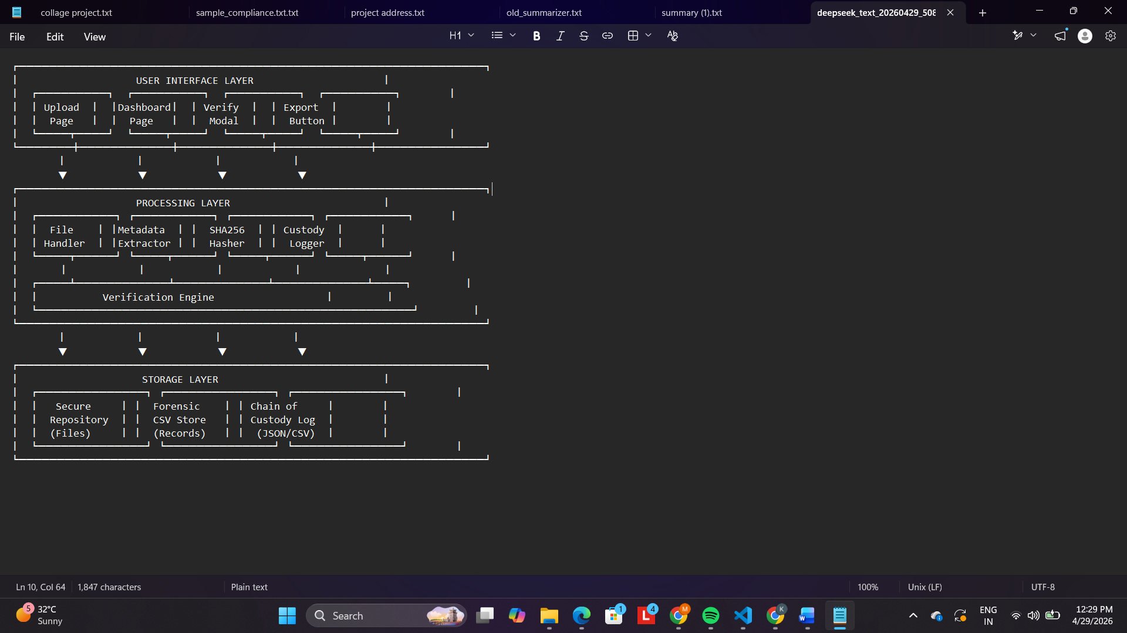
2.2 Process Flow
- User uploads agricultural file (IoT log, sensor data, research file)
- Backend validates file type and size
- File is saved securely with sanitized filename
- Metadata (ctime, mtime, size, path, type) is extracted
- SHA256 hash is computed in chunks (64KB buffer)
- Chain of custody entry is created (action: UPLOAD)
- Forensic record is written to CSV
- File is stored in secure repository
- Dashboard displays all evidence with hash values
- User can verify files (recompute hash and compare)
- User can export full forensic report

2.3 Information Flow
Input:
- Agricultural files (IoT logs, sensor data, research documents, CSV, JSON, binary)
Processing:
- Extract metadata (creation time, modification time, file size, file path, file type)
- Generate SHA256 hash (hexadecimal digest)
- Create custody event with timestamp and action
- Compare hash on verification requests
Output:
- Forensic CSV report with all evidence records
- Dashboard table with filename, hash, timestamp, file size, verification status
- Exportable reports (CSV/JSON format)
- Chain of custody logs

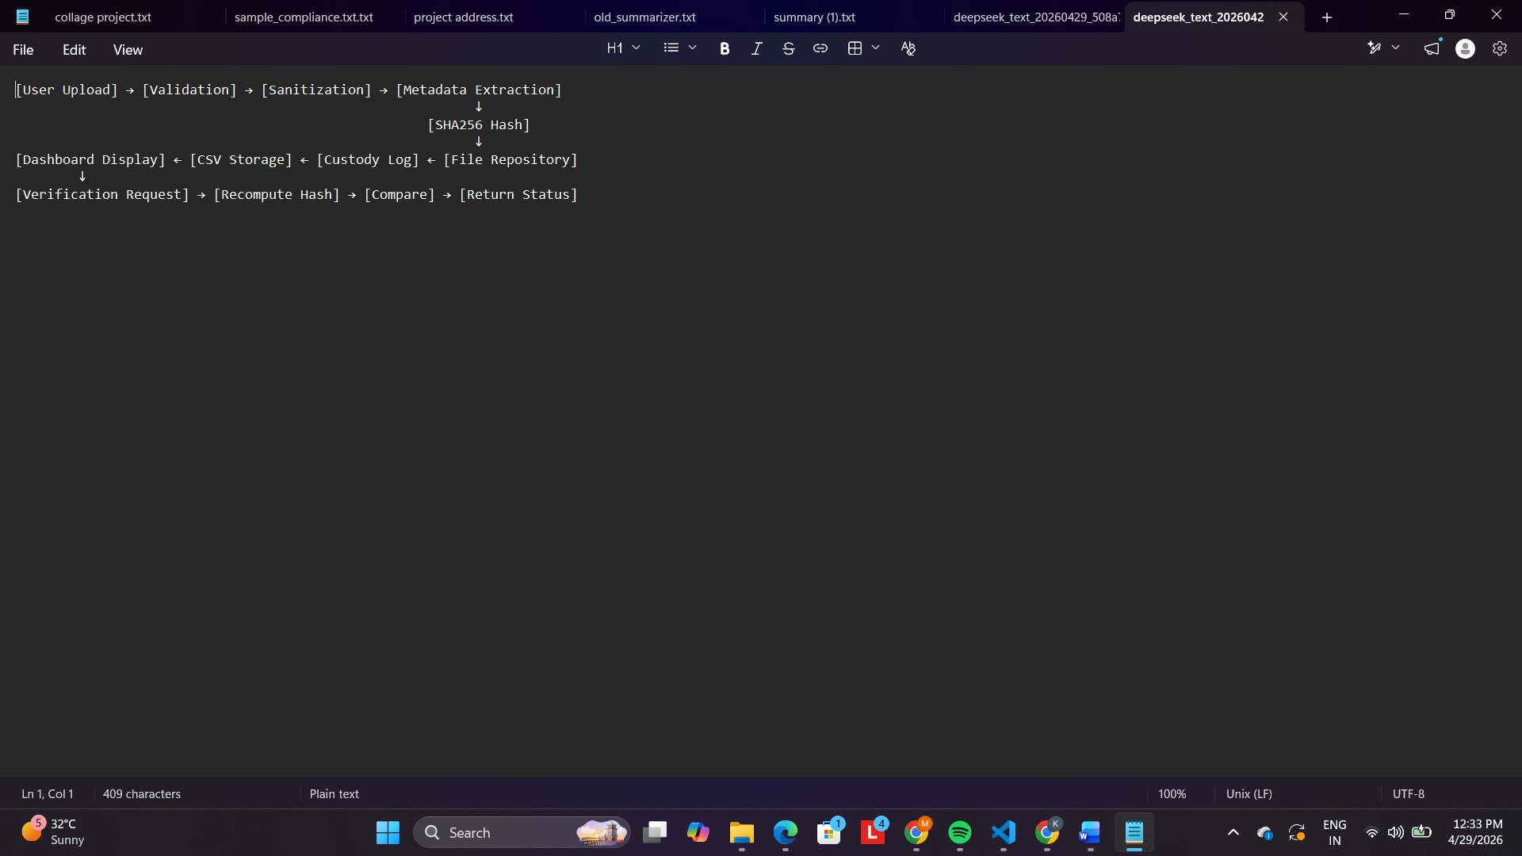
2.4 Components Design
1. File Handling Module
- Handles file upload and secure storage
- Uses secure filename sanitization (secure_filename())
- Validates allowed file extensions (.csv, .json, .log, .txt, .bin)
- Enforces file size limit (100MB for agricultural datasets)
2. Metadata Extraction Module
- Extracts:
  - Creation time (ctime) – filesystem metadata
  - Modification time (mtime) – filesystem metadata
  - File size (bytes)
  - Original file path
  - File type/extension
  - MIME type detection
3. SHA256 Hash Generator
- Reads file in chunks (64KB default buffer)
- Computes SHA256 hash incrementally
- Returns hexadecimal digest string
- Supports re-verification by re-computing hash
4. Chain of Custody Logger
- Logs every action: UPLOAD, DOWNLOAD, VERIFY, EXPORT
- Records: timestamp, action type, file hash, verification result (if applicable)
- Append-only mechanism (no overwriting or deletion)
- Stores as JSON string or separate CSV column
5. CSV Forensics Manager
- Writes structured forensic records
- Reads data for dashboard display
- Exports full report on demand
- Maintains data integrity (no row modification)
6. Dashboard Module
- Displays all evidence records in table format
- Highlights tampered files (hash mismatch on verification)
- Provides action buttons: Download, Verify, View Custody
- Export report functionality
7. Verification Engine
- Re-reads original file from secure repository
- Recomputes SHA256 hash
- Compares with stored hash
- Returns verification status (MATCH / MISMATCH)
- Logs verification event to chain of custody
2.5 Key Design Considerations
Consideration | Decision | Rationale
Simplicity | Monolithic Flask app | Easy to implement and audit
Integrity | SHA256 hashing | Industry standard for tamper detection
Chain of Custody | Append-only logging | Forensic requirement for admissibility
Privacy | Local storage only | No external data exposure
Performance | Chunked hashing (64KB) | Memory efficient for large files
Portability | File-based storage (CSV) | No database setup required
Transparency | Exportable reports | Legal and research audits
2.6 API Catalogue
Endpoint | Method | Request | Response | Description
/upload | POST | multipart/form-data (file) | {file_id, hash, status} | Upload agricultural file
/dashboard | GET | None | HTML page | View all evidence records
/api/records | GET | None | JSON array of forensic records | Get all records (API)
/api/record/<file_id> | GET | None | JSON single record | Get specific record
/download/<file_id> | GET | None | File (attachment) | Download original file
/verify/<file_id> | POST | None | {hash, matches, status} | Recompute hash and verify
/export | GET | format (csv/json) | File download | Export full forensic report
/custody/<file_id> | GET | None | JSON array of custody events | View chain of custody log
/delete/<file_id> | POST | None | {status} | Delete evidence (admin only)

3. Data Design
3.1 Data Model
Forensic Record (CSV Structure):
Field | Type | Description | Example
file_id | string (UUID) | Unique identifier | 550e8400-e29b-41d4-a716-446655440000
filename | string | Original filename | soil_sensor_jan.csv
file_hash | string (64 chars) | SHA256 hexadecimal | e3b0c44298fc1c149afbf4c8996fb92427ae41e4649b934ca495991b7852b855
upload_timestamp | datetime (ISO) | UTC upload time | 2025-01-15T10:30:00Z
file_size | integer | Bytes | 1048576
file_type | string | Extension category | csv
ctime | datetime | Creation time (original) | 2025-01-10T08:00:00Z
mtime | datetime | Modification time | 2025-01-14T09:15:00Z
original_path | string | Original file path | /home/user/data/sensor.log
last_verified | datetime | Last verification time | 2025-01-16T14:20:00Z
verification_status | string | MATCH/MISMATCH/PENDING | MATCH
Chain of Custody Event (JSON stored per file):
Field | Type | Description
timestamp | datetime | Event time (UTC)
action | string | UPLOAD, DOWNLOAD, VERIFY, EXPORT, DELETE
user | string | Admin (single user assumed)
ip_address | string | Optional (for audit trail)
verification_result | string | Only for VERIFY: MATCH/MISMATCH
file_hash | string | Snapshot of hash at event time
3.2 Data Access Mechanism
- File-based storage using CSV for forensic records
- Python csv module for read/write operations
- No ORM – direct file operations
- Separate secure folder for original uploaded files (./secure_repository/)
- Custody logs stored as JSON strings in separate .custody.json files or embedded in CSV
- File naming in repository: {file_id}_{sanitized_filename}
3.3 Data Retention Policies
- Forensic records retained indefinitely (forensic requirement)
- Original files retained until manual deletion by admin
- No automatic cleanup mechanism
- Chain of custody logs are append-only and never deleted
- Export function creates copies for legal archives (does not modify original)

3.4 Data Migration
- Not applicable (no database schema migrations)
- If CSV schema changes in future versions:
  - Python migration script will:
    - Read existing CSV
    - Add new columns with default values
    - Rewrite CSV with new structure
    - Backup original before migration

4. Interfaces
External Interfaces
None – System is fully local with no external dependencies or API integrations.
User Interface
Page | Description | Key Elements
Upload Page | File submission interface | Drag-drop zone, file picker, upload button, progress indicator
Dashboard Page | Evidence management | Table with all records, search/filter, action buttons (Download, Verify, Custody)
Verification Modal | Hash verification results | Shows recomputed hash, comparison status, timestamp
Custody Modal | Chain of custody viewer | Timeline of all actions on a file
Export Panel | Report generation | Format selection (CSV/JSON), export button
Configuration Interface
Flask configuration variables:
Variable | Default Value | Purpose
UPLOAD_FOLDER | ./secure_repository | Path for stored files
FORENSIC_CSV_PATH | ./forensic_records.csv | Path for master CSV
CUSTODY_LOG_FOLDER | ./custody_logs/ | Path for custody JSON files
MAX_CONTENT_LENGTH | 100MB | Maximum file upload size
ALLOWED_EXTENSIONS | {'csv','json','log','txt','bin'} | Permitted file types
HASH_CHUNK_SIZE | 65536 (64KB) | Buffer size for hashing
SECRET_KEY | (random generated) | Flask session security

5. State and Session Management
- Session Type: Flask session (client-side cookie, cryptographically signed)
- Session Data:
  - session_id – Unique session identifier
  - authenticated – Boolean (true for single admin user)
  - upload_progress – Optional (for large file tracking)
- No persistent session storage – Sessions are stateless between server restarts
- Chain of custody log is independent of session – Forensic requirement for immutability
- Session timeout: 30 minutes of inactivity
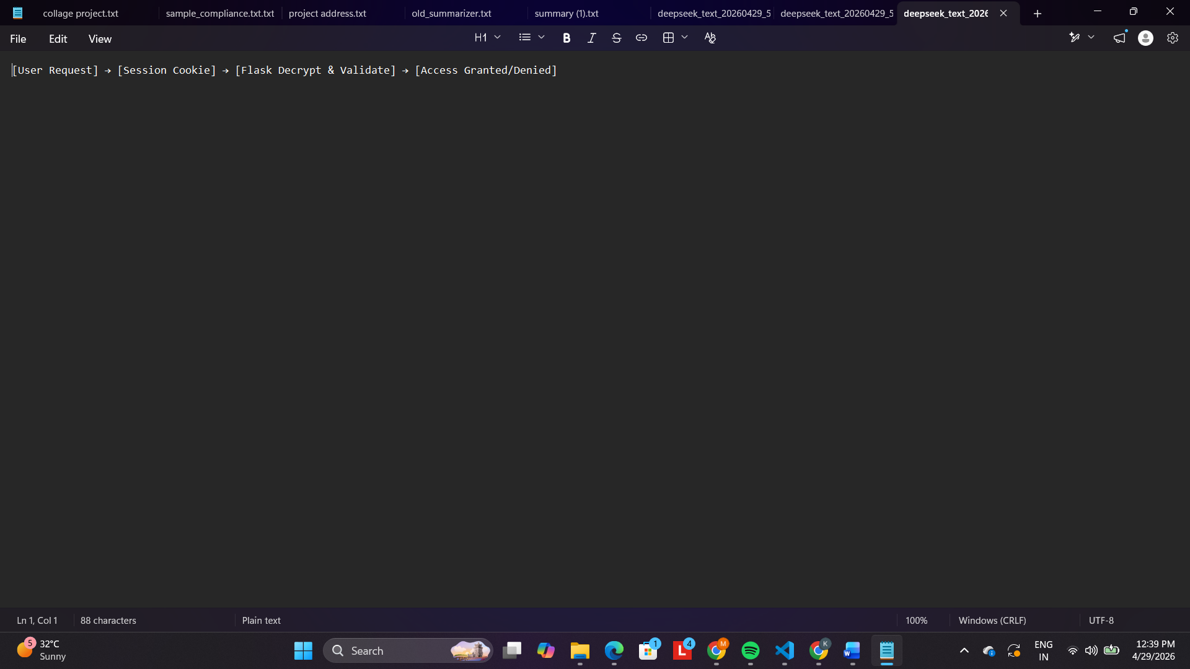

6. Caching
- No caching implemented – Forensic systems must process real-time data
- Every upload triggers fresh hash computation (cannot use cached hash)
- Every verification re-reads file from disk (ensures current state)
- Dashboard reads CSV directly on each request (no cache invalidation complexity)
- Rationale: Caching could lead to stale forensic data, violating chain of custody principles

7. Non-Functional Requirements
7.1 Security Aspects
Requirement | Implementation
Path traversal prevention | secure_filename() + file_id renaming
File size limit | 100MB cap (configurable)
Tamper detection | SHA256 hash verification
Chain of custody immutability | Append-only logs (no overwrite)
No external exposure | Localhost binding only (127.0.0.1)
Hash collision resistance | SHA256 (NIST approved)
Secure file storage | Files stored by UUID, not original names
Input validation | File type whitelist (extensions + MIME)
7.2 Performance Aspects
Metric | Target | Implementation
Upload (10MB file) | < 2 seconds | Chunked hashing, async write
Upload (100MB file) | < 15 seconds | 64KB buffer, streaming
Hash generation speed | ~3 MB/sec | Optimized chunk size (64KB)
Dashboard load (500 records) | < 1 second | CSV lazy loading
Dashboard load (5000 records) | < 3 seconds | Pagination/limit implemented
Verification (100MB file) | < 15 seconds | Same as upload hashing
Concurrent users | 1 (single-user) | No locking complexity
Memory usage | < 200MB | Streaming reads, no full file loading
7.3 Availability
- System runs locally – availability = user's machine uptime
- No external dependencies = 100% available if machine is running
- Data persists across restarts (CSV + file repository)
7.4 Maintainability
- Modular component design (easy to replace hashing algorithm)
- Configuration via environment variables
- No database migrations to manage
- Logging for debugging and audit trails

8. References
- Flask Documentation
Official documentation for Flask framework used in backend development
https://flask.palletsprojects.com/
- Python hashlib Module
SHA256 cryptographic hash generation
https://docs.python.org/3/library/hashlib.html
- Python os Module Documentation
Used for file metadata extraction (ctime, mtime, file size)
https://docs.python.org/3/library/os.html
- Chain of Custody Best Practices
NIST Digital Forensics Guidelines
https://www.nist.gov/
- SHA256 Cryptographic Hash Standard
NIST FIPS PUB 180-4
https://csrc.nist.gov/publications/detail/fips/180/4/final

- AAppendix A: Comparison with Cloud Forensics System
Aspect | Cloud Forensics (Original) | Agriculture Forensics (New)
Primary Purpose | Tamper detection (timestamps) | Integrity + Chain of Custody
Hashing | None | SHA256
Custody Logging | No | Yes (append-only)
Verification Method | Timestamp comparison | Hash recomparison
File Types | General | Agricultural (IoT, sensor, research)
Export Format | CSV only | CSV + JSON
Dashboard Actions | View only | Download, Verify, Custody, Export
Data Retention | Manual deletion | Immutable logs + manual deletion

